 | 12.1.12 Editors - Geometry Nodes Editor - Header - Add Menu - Input - Scene
Table of content
Detailed table of content 1
Add menu - Input - Scene 2
Collection Info 2
Image Info 3
Is Viewport 4
Object Info 5
Self Object 5
Scene time 5

Detailed table of content
Detailed table of content
Detailed table of content 1
Add menu - Input - Scene 2
Collection Info 2
Inputs 2
Collection 2
Properties 3
Transform Space 3
Original 3
Relative 3
Outputs 3
Geometry 3
Image Info 3
Input 3
Image 3
New 3
Open 3
Image prop 3
Image browser 3
Image name 3
Fake user 4
New 4
Open Image 4
Remove 4
Frame 4
Outputs 4
Width 4
Height 4
Has Alpha 4
Frame Count 4
FPS 4
Is Viewport 4
Outputs 4
Is Viewport 4
Object Info 5
Inputs 5
Object 5
Outputs 5
Location 5
Rotation 5
Scale 5
Geometry 5
Self Object 5
Scene time 5
Outputs 5
Seconds 5
Frame 5

Add menu - Input - Scene
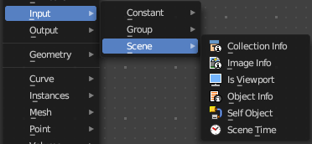
Here you find input nodes.

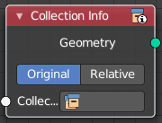
Collection Info
The Collection Info node retreives information from collections. This can be useful to use an external collection to control parameters in the geometry node tree.

Inputs

Collection
Collection to get the properties from.

Properties

Transform Space
The transformation of the geometry outputs.

Original
Output the geometry relative to the collection offset.

Relative
Bring the input collection geometry into the modified object, maintaining the relative position between the objects in the scene.

Outputs

Geometry
Geometry of the collection in world space with all its modifiers applied.

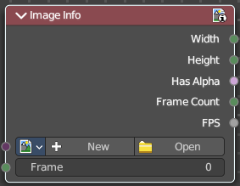
Image Info
Retreive infos from an image.

Input

Image
Load or connect a image.

New
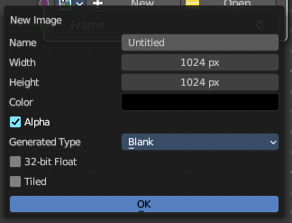
Create a new image.
Opens a new image dialog where you can adjust the color, size and further settings.

Open
Open a existing image.

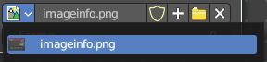
Image prop

Image browser
A list of available images

Image name
The name of the image

Fake user
Add a fake user to this asset.

New
Create a new image.
Opens a new image dialog where you can adjust the color, size and further settings.

Open Image
Open a existing image.

Remove
Removes the image as the active image.

Frame
For videos. Which frame to use.

Outputs

Width
The width of the image.

Height
The height of the image

Has Alpha
Returns true if the image has an alpha channel

Frame Count
For movies. How many frames.

FPS
For movies, what FPS rate.

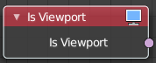
Is Viewport
The Is Viewport node outputs true when geometry nodes is evaluated for the viewport. For the final render the node outputs false.

Outputs

Is Viewport
A booleran that indicates if the geometry nodes is evaluated for preview.

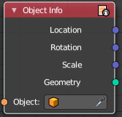
Object Info
The Object Info node retreives information from objects. And outputs it then.

Inputs

Object
Object to get the properties from.

Outputs

Location
Location of the object in world space.

Rotation
Rotation of the object in world space.

Scale
Scale of the object in world space.

Geometry
Geometry of the object in world space with all its modifiers applied.

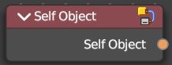
Self Object
Retreives the parent object of the geometry nodes.

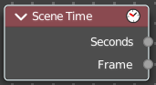
Scene time
Outputs the current scene time in seconds or in frames.
The Frame output is a float value to make subframe rendering for motion
blur possible.

Outputs

Seconds
Output in seconds.

Frame
Output in Frames.

